CONSTRUCTION PRODUCTS REGULATION
DECLARATION OF PERFORMANCE
No: STIXCLEAR/2-CPR/ 2014
Substrate: Anodized Aluminium
Primer: No primer used
1. Identification Code | STIXALL CRYSTAL CLEAR  Codes: STIXCLEAR
2. Type, Batch and/or Serial Number | - For batch number - see packaging
3. Intended use | Sealant for non-structural use in joints in buildings and pedestrian walkways Part 1: Sealants for Façade elements
4. Manufacturer | Everbuild Building Products ltd, Site 41, Cross Green Industrial Estate, Knowsthorpe Way, Leeds, LS9 0SW
5. Authorised Representative | Not Applicable
6. Assessment and Verification of Constancy of Performance | System 3
7. Notified Body and Tasks | SKZ Notified Body No. 1213
8. European Technical Assessment | Not Applicable
9. Declared Performance TO EN15651-1 (2012)
Type | F EXT-INT-CC
Classification | F20LM
Reaction to Fire | Class E
Loss of Volume ISO10563 | ≤10%
Resistance to flow ISO7390 | ≤3 mm
Adhesion/cohesion properties at maintained extension after water immersion (23°C) ISO 10590 | NF
Adhesion/cohesion properties (-30°C) | NF
Durability | Pass

Substrate: Anodized Aluminium
Primer: No primer used
1. Identification Code | STIXALL CRYSTAL CLEAR  Codes: STIXCLEAR
2. Type, Batch and/or Serial Number | - For batch number - see packaging
3. Intended use | Sealant for non-structural use in joints in buildings and pedestrian walkways Part 3: Sealants for Sanitary elements
4. Manufacturer | Everbuild Building Products ltd, Site 41, Cross Green Industrial Estate, Knowsthorpe Way, Leeds, LS9 0SW
5. Authorised Representative | Not Applicable
6. Assessment and Verification of Constancy of Performance | System 3
7. Notified Body and Tasks | SKZ Notified Body No. 1213
8. European Technical Assessment | Not Applicable
9. Declared Performance TO EN15651-3 (2012)
Type | S
Classification | XS2
Reaction to Fire | Class E
Loss of Volume ISO10563 | ≤20%
Resistance to flow ISO7390 | ≤3 mm
Adhesion/cohesion properties at maintained extension after water immersion (23°C) ISO 10590 | NF
Action of the microorganisms : Intensity of growth ISO 846, method B | 1
Durability | Pass

The performance of the product identified in points 1 and 2 is in conformity with the declared performance in point 9 . The declaration of performance is issued under the sole responsibility of the manufacturer identified in point 4.

Signed: I. G. Southerington – Head of Technical P.R. Thomas – Technical Manager
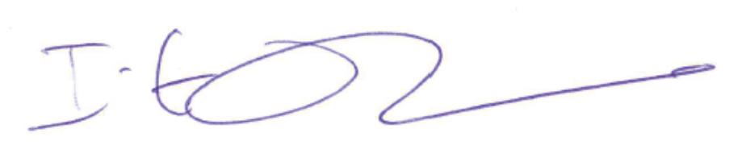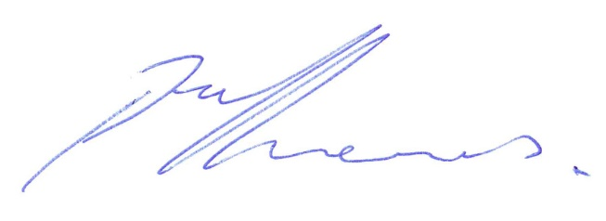
Dated: Leeds, 16/6/14

