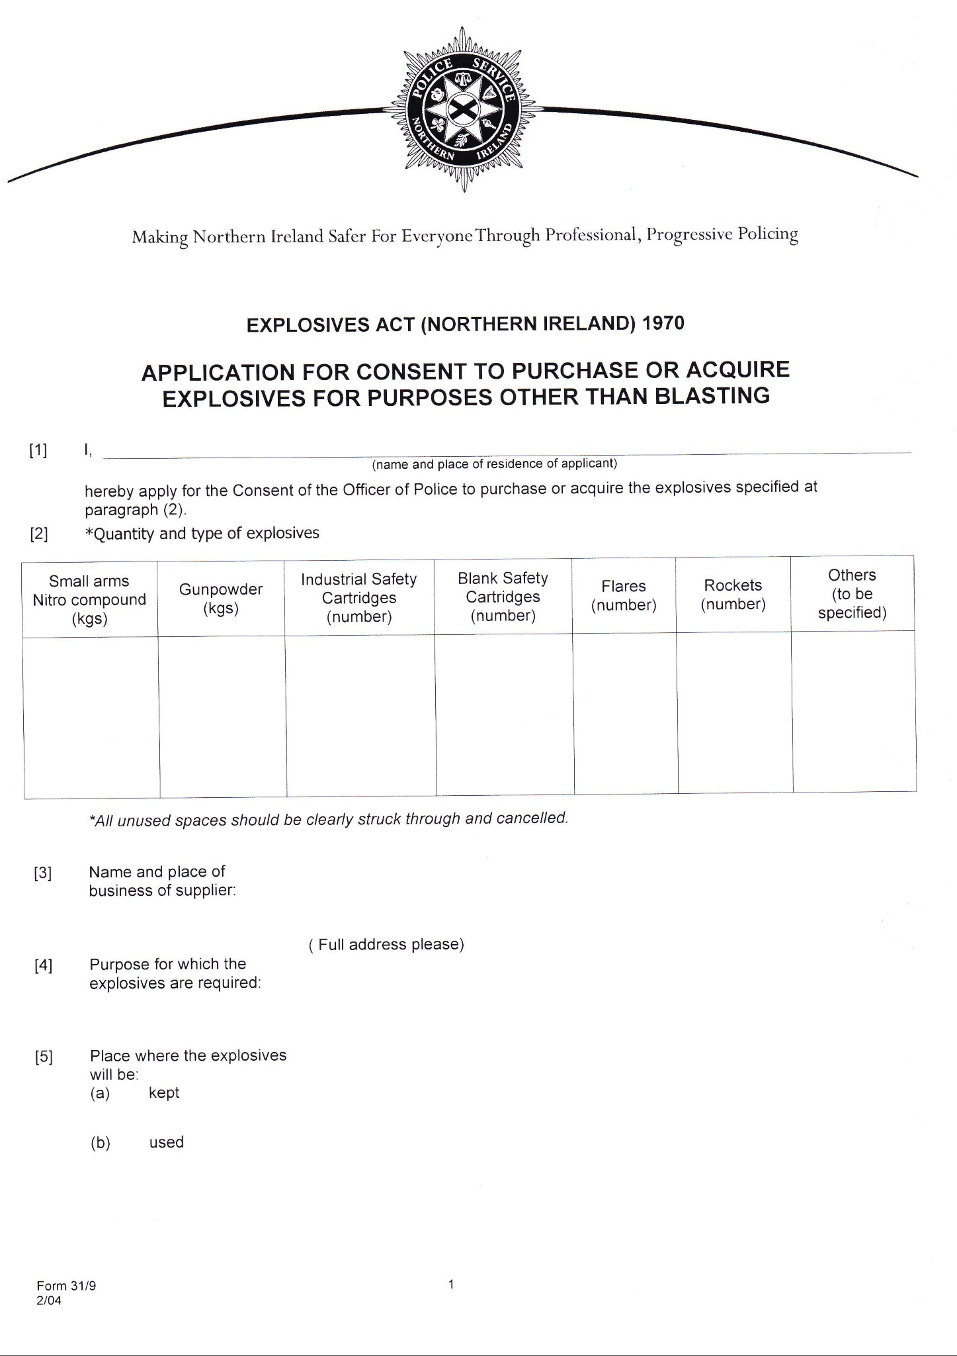

**PMH Supplies Ltd. Unit 15 Craigstown Rd Ind. Est., Craigstown Rd,**

**Randalstown, Co. Antrim, BT41 2PT**

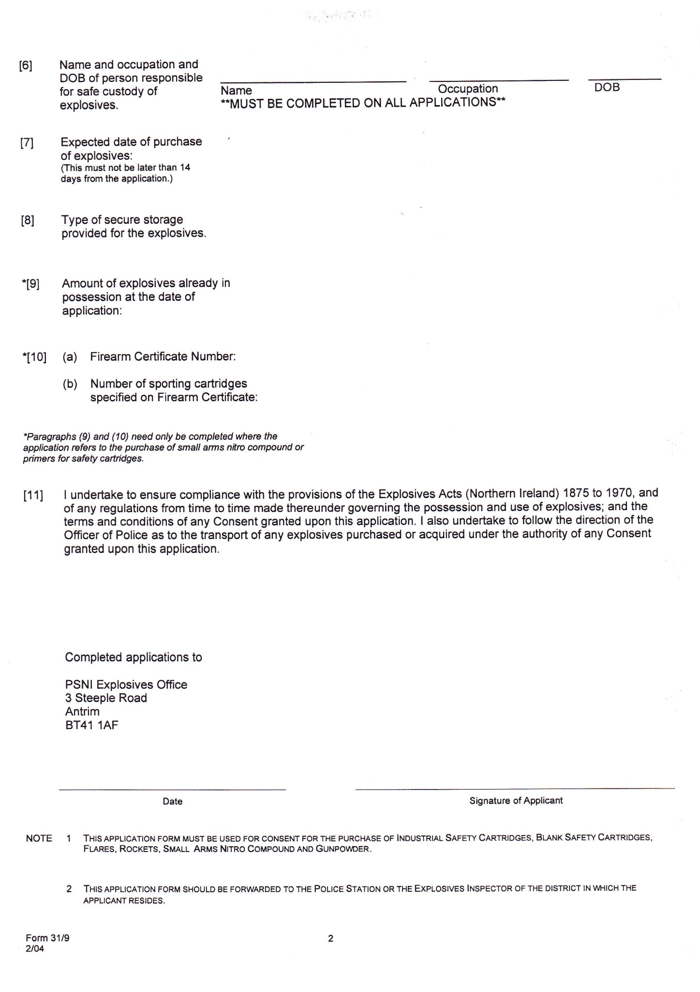

XXXXXXX

XXXXXXX