5, 30 & 45MINUTE PU WOOD ADHESIVES

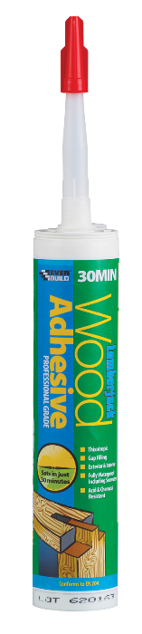
Colour | Product Code | Pack Size | Box Qty
Trans | 5MINPU3 | 310ml | 12
Red | 5MINPU7 | 750gm | 6
Red | 5MINPU01 | 125gm | 12
Trans | 30MINPU3 | 310ml | 12
Brown | 30MINPU7 | 750gm | 6
Brown | 45MINPU7 | 750gm | 6

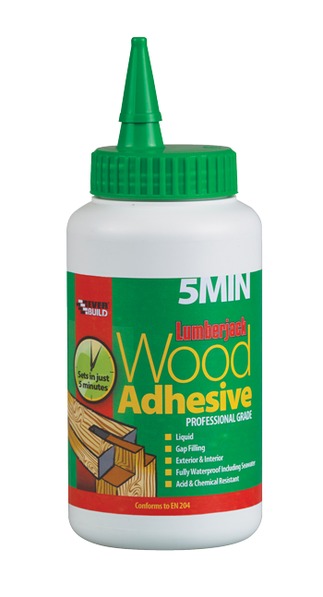

Product Description
Lumber Jack 5 min, 30 min & 45min Polyurethane Wood Adhesives are professional quality one part moisture curing wood adhesives with rapid setting properties. These products are available in three forms:
- A 30 minute set cartridge applied thixotropic gel – LUMBER JACK 30 MINUTE POLYURETHANE WOOD ADHESIVE
- A 5 minute set cartridge applied thixotropic gel - – LUMBER JACK 5 MINUTE POLYURETHANE WOOD ADHESIVE
- A 30-minute set free flowing liquid in a bottle - – LUMBER JACK 30 MINUTE POLYURETHANE WOOD ADHESIVE LIQUID.
- A 5-minute set free flowing liquid in a bottle - – LUMBER JACK 5 MINUTE POLYURETHANE WOOD ADHESIVE LIQUID.
- A 45-minute set free flowing liquid in a bottle - – LUMBER JACK 45 MINUTE POLYURETHANE WOOD ADHESIVE LIQUID.

As well as bonding all common wood types (hard, soft, exotic, painted) LUMBERJACK PU WOOD ADHESIVES will also bond Formica, polystyrene, PU foam metal and glass wool and various plastics (including PVC) to porous surfaces. These products also adhere to stone, concrete, brick and masonry.

Benefits
- Fast setting – 45, 30 minute or 5 minute set (Typical PVA based wood glue – 8-12 hours)
- Exceptional bond strength to wood and most common building surfaces.
- Internal and external use - excellent weathering and aging properties.
- Fully water proof to EN204 D4, including seawater.
- Products foam slightly on application to fill small gaps and increase overall bond strength.
- Excellent Chemical Resistance.

Areas For Use
- General wood jointing and construction
- Window and door frame manufacture
- Door manufacture
- Furniture manufacture
- Boat building
- Construction of staircases and ladders
- As a high quality insulation adhesive for foam/glasswool/fibre boarding

Limitations
- At least one of the surfaces to be bonded must be porous.
- Not suitable for polyethylene, polypropylene, Teflon or Nylon.
- Surfaces may be damp, but moisture content of wood must not exceed 30%w/w.
- As product expands slightly on curing, do not use on sheet laminate. Use STICK 2 CONTACT ADHESIVE.
- Only apply between + 5 and + 30ºC.
- Ensure surfaces are always clamped during use.
- Setting times will be increased at low temperatures and low humidity.

Surface Preparation
The surfaces to be glued should be clean and free from dust, grease and other contaminants. At least one of the materials must be porous. Roughen non-porous surfaces to give a key for the adhesive. To assist cure and achieve maximum bond strength, slightly moisten one surface with a damp cloth. Do not over wet.

Application
Cartridge Products: Cut tip of cartridge taking care not to damage the thread. Fix nozzle, cut to required aperture and apply using standard sealant gun.
Liquid version: Remove cap, cut spout and apply. Replace cap after use.
Wearing of gloves is recommended. Apply adhesive evenly to one surface. If necessary, cover large areas with a fine toothed spreader. Assemble parts IMMEDIATELY and clamp for duration of cure (5-30 minutes at 20ºc; longer at lower temperatures). After this time, the joint may be easily handled. Full and final bond strength will be achieved after 30 minutes for 5 minute set or 24 hours for 30 minute set.
NOTE: These products foam slightly on application to fill small gaps. Any excess foam/adhesive must be removed with acetone before the product sets or with a sharp chisel once set.

Specific Data
Colour | Gels: Translucent  Liquid: 5 Min: Red, 30 Min: Brown
Contents | 100% prepolymers and catalyst (solvent free)
Solids | 100% (solvent free)
Viscosity | 200 x10³ mPa.s (bfld RVT sp7 5rpm) (gel)
Coverage | 400g/m², or 10 linear meters per tube (approx)
Initial Set Time | 5,30 or 45minutes, depending on product
Flash Point | N/A
Cleaner | Everbuild Dual Purpose Foam Cleaner or acetone BEFORE curing. After cure, use mechanical abrasion.

Health & Safety
Consult MSDS for full list of hazards.

Storage
Store in original unopened containers between 10 and 25ºC. Reseal immediately once used or disposal will be necessary

Shelf Life
Twelve months from date of manufacture in original unopened containers.
The technical data contained herein is based on our present knowledge and experience and we cannot be held liable for any errors, inaccuracies, omissions or editorial failings that result from technological changes or research between the date of issue of this document and the date the product is acquired. Before using the product, the user should carry out any necessary tests in order to ensure that the product is suitable for the intended application. Moreover, all users should contact the seller or the manufacturer of the product for additional technical information concerning its use if they think that the information in their possession needs to be clarified in any way, whether for normal use or a specific application of our product. Our guarantee applies within the context of the statutory regulations and provisions in force, current professional standards and in accordance with the stipulations set out in our general sales conditions. The information detailed in the present technical data sheet is given by way of indication and is not exhaustive. The same applies to any information provided verbally by telephone to any prospective or existing customer.

