CONSTRUCTION PRODUCTS REGULATION
DECLARATION OF PERFORMANCE
No: STIX/1-CPR/ 2014
Substrate: Mortar M1
Primer: No primer
1. Identification Code | STIXALL (COLOURS)  Codes: STIXBK/BN/GY/WE
2. Type, Batch and/or Serial Number | - For batch number - see packaging
3. Intended use | Sealant for non-structural use in joints in buildings and pedestrian walkways Part 1: Sealants for Façade elements
4. Manufacturer | Everbuild Building Products ltd, Site 41, Cross Green Industrial Estate, Knowsthorpe Way, Leeds, LS9 0SW
5. Authorised Representative | Not Applicable
6. Assessment and Verification of Constancy of Performance | System 4
7. Notified Body and Tasks | Not Applicable
8. European Technical Assessment | Not Applicable
9. Declared Performance TO EN15651-1 (2012)
Type | F INT
Classification | F INT
Reaction to Fire | Class E
Loss of Volume ISO10563 | ≤45% (RESULT 3.6%)
Resistance to flow ISO7390 | ≤3 mm
Adhesion/cohesion properties after water immersion (23°C) ISO 10591 | ≥25%
Durability ISO 8339 and ISO 10591 | Pass

The performance of the product identified in points 1 and 2 is in conformity with the declared performance in point 9 . The declaration of performance is issued under the sole responsibility of the manufacturer identified in point 4.

Signed: I. G. Southerington – Head of Technical P.R. Thomas – Technical Manager
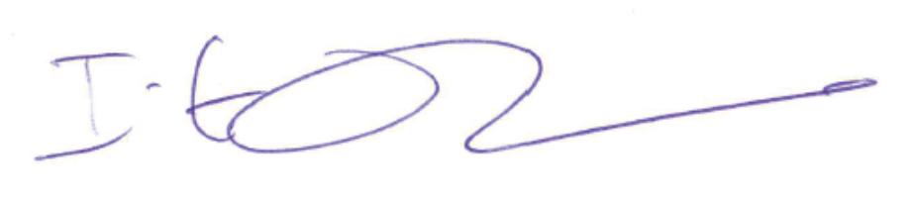
Dated: Leeds, 23/4/14

